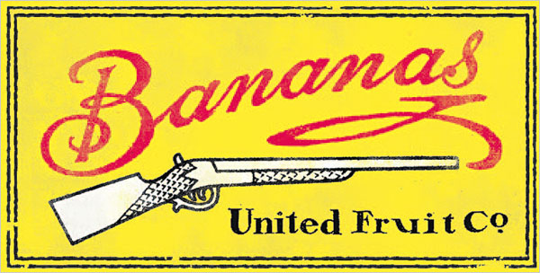
The history of banana growing in Central America is closely tied to the history of politics in the same area from the 1880's through the 1970's. Prior to 1870, bananas were unknown in the United States. The first bananas were imported to the U.S. in 1870 and just 28 years later, Americans in the U.S. were consuming over 16 million bunches a year. The story begins in 1871 with the construction of a railroad in Costa Rica by an industrious 23 year old from Brooklyn named Minor Keith. The project cost hundreds of lives, including the lives of his two brothers. Keith was a man who would do anything to advance his own interests. He even married the daughter of the Costa Rican President. His efforts paid off and eventually he earned the title The Uncrowned King of Central America.
While Keith was building the railroad in Costa Rica he was also executing a much bigger plan. As construction progressed, he planted bananas on the land easements to either side of the tracks. The bananas flourished and with the railroad completed it was possible to economically transport the bananas to eager markets in the United States and Europe. Ten years later, Keith owned three banana companies. Keith then joined up with a Cape Cod sailor, Captain Lorenzo Baker and a Boston businessman, Andrew Preston. Together they raised the money to found the Boston Fruit Company. In 1899, the Boston Fruit Company and the United Fruit Company (UFCO) merged, thus forming the largest banana company in the world with plantations in Colombia, Costa Rica, Cuba, Jamaica, Nicaragua, Panama and Santo Domingo. They also owned eleven steamships, known as the Great White Fleet plus 30 other ships rented or leased. The company also owned 112 miles of railroad linking the plantations with ports. Until its demise a hundred years later, United Fruit controlled as much as 90 percent of the market.
Throughout all of this, United Fruit defined the modern multinational corporation at its most effective — and, as it turned out, its most pernicious. At home, it cultivated clubby ties with those in power and helped pioneer the modern arts of public relations and marketing. (After a midcentury makeover by the “father of public relations,” Edward Bernays, the company started pushing a cartoon character named Señorita Chiquita Banana.) Abroad, it coddled dictators while using a mix of paternalism and violence to control its workers. “As for repressive regimes, they were United Fruit’s best friends, with coups d’état among its specialties.” United Fruit had possibly launched more exercises in ‘regime change’ on the banana’s behalf than had even been carried out in the name of oil.
There are echoes of United Fruit today. For example, the company’s successor in the banana business, Chiquita Brands International, has admitted to paying nearly $2 million to right-wing death squads in Colombia. And the blow-back from United Fruit’s way of doing business still haunts Latin America. Just look at Guatemala — once United Fruit’s most treasured possession, now one of the Western Hemisphere’s most violent countries.

