Mr. Gorham Name: ________________________________________
U.S. History II: Modern American History
First Week of Class Due: ______________

“Big Business and Labor” -- Ch. 14, Sec. 3 (10 pts.)

- What is the Main Idea of this section? (Hint: top left p. 447).

Carnegie’s Innovations

- Andrew Carnegie came to control what industry?

- Describe the difference(s) between vertical and horizontal integration?

Social Darwinism and Business

- Briefly describe biological Darwinism.

- Who would succeed in Social-Darwinism and who would fail? What kind of traits would make one economically successful?

- Do you think some people are destined by nature to lead lives of hard work and drudgery for low wages while others are destined from birth lead to wealthy, fabulous lives?

Fewer Control More

- What is a monopoly?

- What industry came to be controlled by John D. Rockefeller through these corporate devices?

- Why would the Sherman Antitrust Act be good for consumers?

Labor Unions Emerge

- What is a labor union?

- At the turn of the century, a woman forced to work in America would make $267 per year. Assuming a 60-hour week and no weeks off, how much would she have earned per hour?

- How much did Andrew Carnegie make in 1900? What is that in today’s dollars (use internet calculator).

Current Events Question
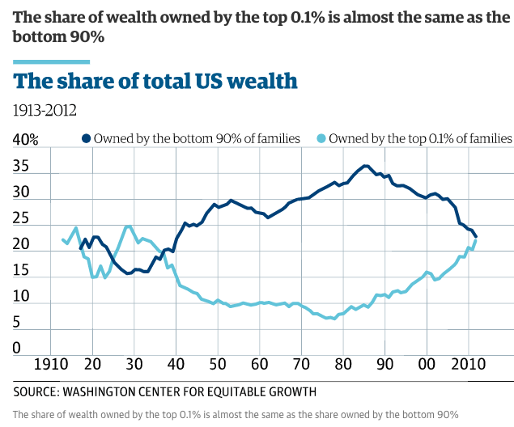
13. Using the chart above, in what three time periods did America’s wealthiest families take the greatest share of all national wealth?

Historiography Question

14. Historiography is the history of history. Rather than analyzing the actual events--say, Hitler's annexation of Austria--the subject of historiography is the history of the history of the event: the way it has been written, the sometimes conflicting objectives pursued by those writing on it over time, and the way in which such factors shape our understanding of the actual event at stake, and of the nature of history itself.

Robert E. Lee was a Civil War General who fought for the Confederacy. How might southern and northern historians differ in their study of General Lee?

