Mr. Gorham Name: _____________________
Modern American History
First World War
The First Day
Aug. 23, 1914

The first day. In this two-day lesson, we will be there as the British Expeditionary Force meets the German Army for the first time in WWI. At the chaotic Battle of Mons, you will meet Lt. Dease, Pvt. Holbrook, and Sid Godfrey. The BBC drama "Our World War" is based on primary sources of these men.

Notes: subtitles are needed for ep. 1, “The First Day.” Episodes 2 & 3 are available on Netflix/Amazon but unfortunately will not get in-class time. I invite you to seek those out!

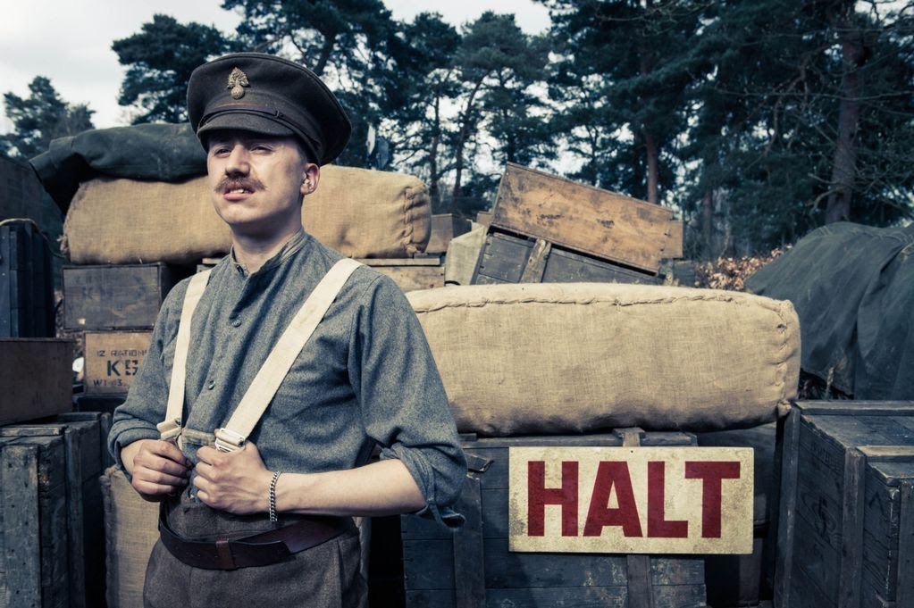

Note: When he encounters the wounded and captured German cavalryman, Lt. Dease remarks that the German soldiers are conscripts, while the British are professionals. What is the difference?

Casualties: refers to KIA (killed in action). MIA (missing in action) and badly wounded.

In your WWI Paper, you may refer to this episode and the real soldiers who are depicted here: Lt. Dease, Lt. Steele, Pvt. Godfrey, runner Holbrook, and Sapper Neary.

BEF was 80,000 strong; 1,600 casualties at Mons.
150,000 strong at Mons, but between 800,000 and 1M invaded Belgium. Suffered 5,000 casualties in the one-day battle of Mons.

